Archive a Patient in Pinnacle

**Note:**The Pinnacle username and password are both [redacted]. You may need to type in the password and press enter, twice.

1. From Launch Pad, left-click the *Backup* icon.

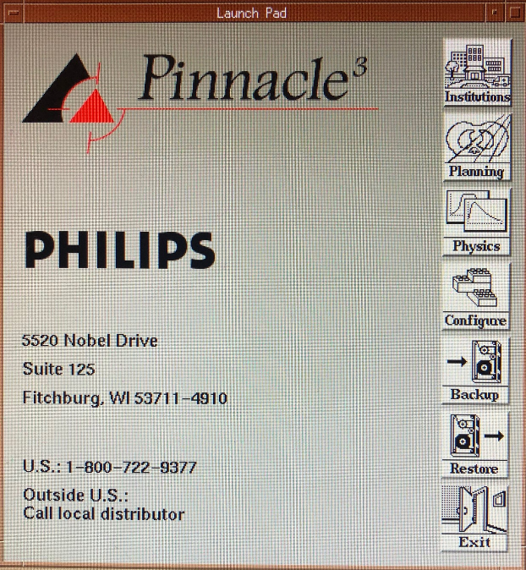

The *Backup* window should appear.

1. Ensure that *UNIX File* is selected (green).
2. Add */NASarchive* as well as the patient’s full name and MR number to the file path. For example, to archive John Smith with MR #000123456, the path should be */home/[redacted]/NASarchive/smithjohn000123456*.
3. Left-click the arrow beside the institution name that contains the patient’s files. The institutions roughly correspond to Pinnacle versions. Use the binders in the cabinet above [redacted]’s diploma to determine which institution contains the patient’s files.
4. Left-click the arrow beside the *Patients* subfolder. Left-click the patient’s name.

>>

1. Left-click .
2. Left-click .

Start Backup

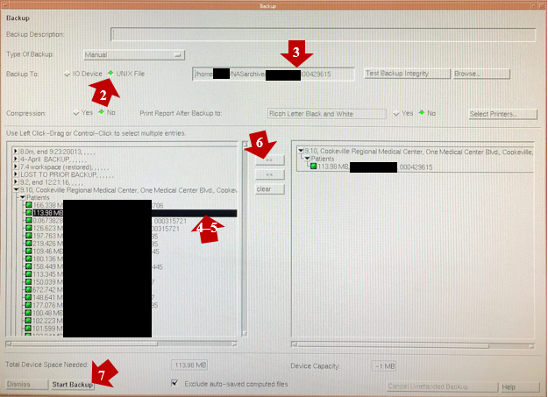

Yes

1. Click in the dialog box that appears.